

**SVKM’s NMIMS**

**Mukesh Patel School of Technology Management & Engineering, Shirpur**

**A REPORT ON**

**“Travel Agency Mini Project”**

By

Isha Keshariya (N-250)

Vrinda Arora (N210)

Herchelle Nandwana (N261)

MBA Tech (Computer Engineering) III Year

Academic Year 2021-22

# “Khush Travels”

# **ABSTRACT**

The final project of this course this semester is the website of a Travel Agency. It is supposed to execute common features of website. A user should be able to use his own username and password to access the webpage and perform corresponding operations according to his user type. For example, an individual can make booking keeping it budget friendly and the owner can add more packages.

**INTRODUCTION**

As technology advances internet is becoming ever popular. Website has become an essential part. Often website of a Company is used as major requirements to rate it. Thus having a website is essential for any major organization. As one of the sector which require this the most is the Travelling sector. Systems needs to have a useful and stunning website to showcase the work and use as a medium to interact with user, agent and others. Planning major places to visit, group activates etc. can be the major advantages of a website.

On this project we will develop a website for an agency naming KHUSH TRAVELS. On this report almost every details that is necessary has been discussed. Although maximum effort has been given to estimate events and expenses. There are some optional features that can be included or excluded. But the plus point is we will get 24/7 support. Cost can be minimized according to the users need, but a luxury experience has been given priority over cost.

The work will be done by a team with a supervisor from faculty member. Knowledge of web development and software’s has been used to make the websites work successfully. Some screenshots have been attached to get clear picture of the project. Every possible disclosure has been made to cover maximum areas of the project.

## **PROBLEM STATEMENT AND SOLUTION**

*Why this mini project is implemented, which problem it is solving? What is the solution of the problem?*

Since travels and tours are the hastily flourishing field and there is a need to furnish an online facility. And when we talk about bookings, travelers often face difficulties in maintain the documentation and wander at individual websites for bookings. To all the intense travel freaks out there so they could effortlessly spot and book the hotels, flights, trains and busses at the price which is pocket friendly and they could rejoice their level best on their trip. So, the issue is to deliver a modest yet complete website where all the details are provided to the user/client in one place only.

Keeping the concerns of travelling freaks in psyche we, the team, “***Tech Dudes”***, have attempted to implement our understanding of Web Programming and the languages learnt herein to construct a simple yet efficient website so that the users can easily book the hotel and medium of conveyance of their preference. And they can make it even more easy by a simple selection of package.

**LIST OF TECHNOLOGIES USED**

Languages which we have utilized to design this web page are:

1. HTML

2. CSS

3. JS

4. PHP

5. PHP with MySQL

The software used here are:

1. VS code

2. NET Beans

3. Filmigo (for video making)

## **PROJECT GALLERY**

* *Elaborate each page output with 2-3 lines.*
* *One page can have two print screen.*
* *Each print screen should have figure number and name*

**1. Landing Page:**

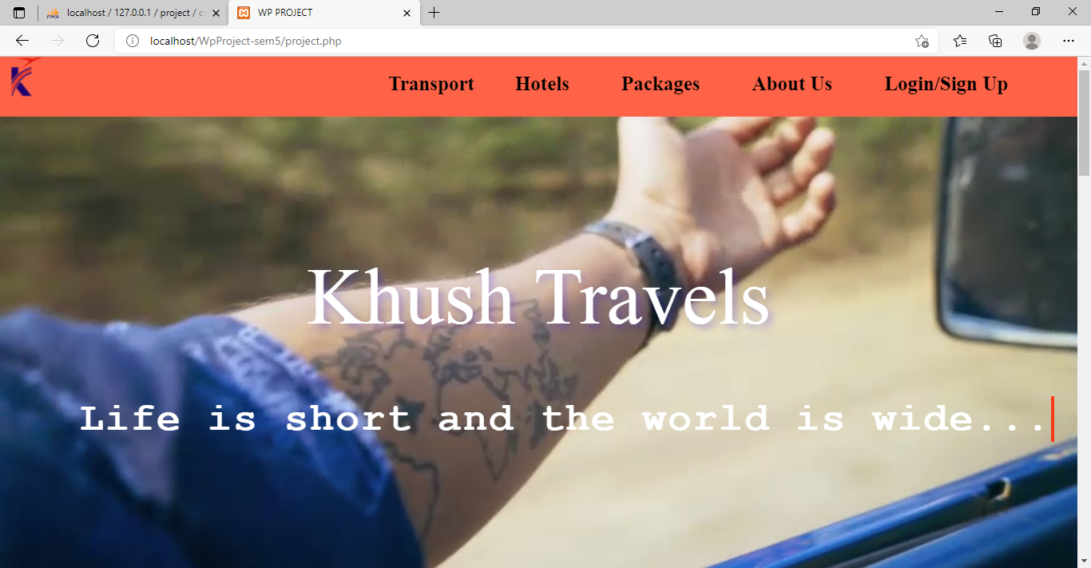



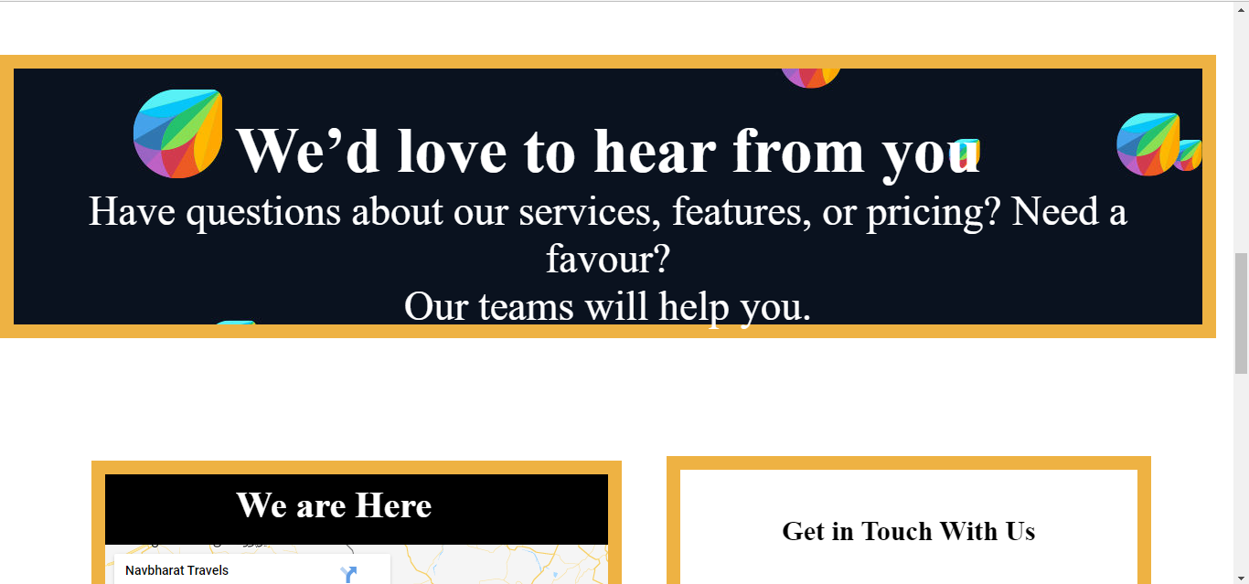

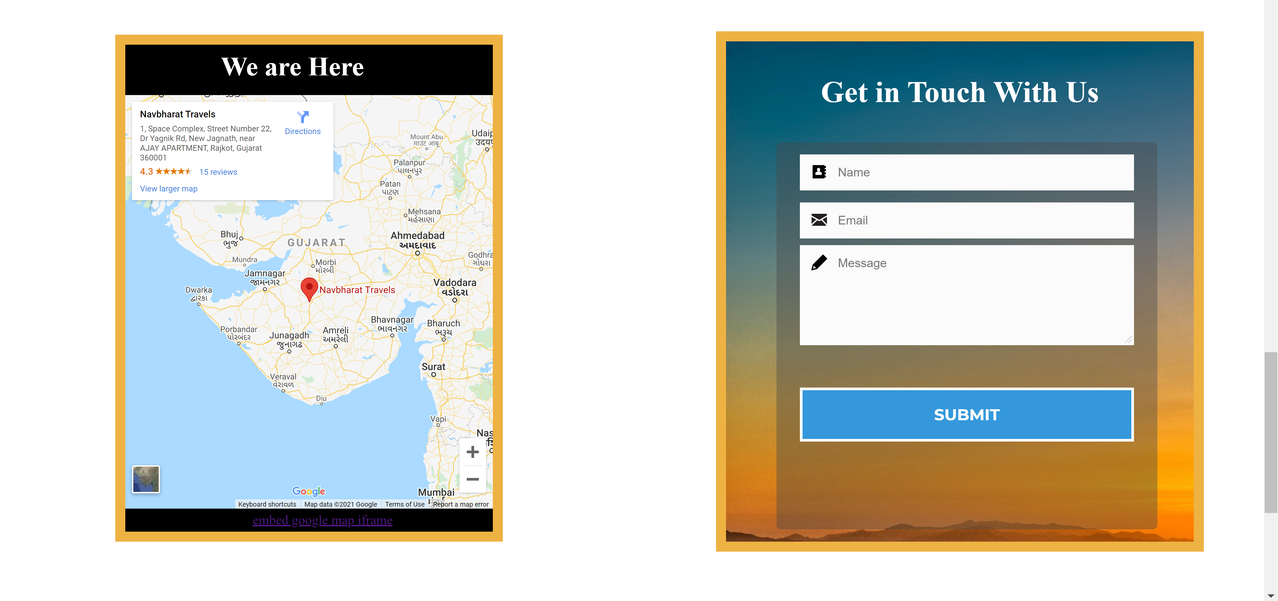

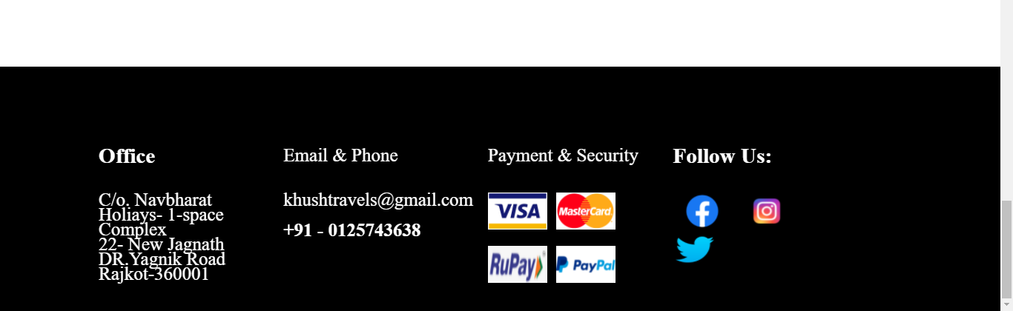

**2. Page that pops up when user clicks Flights option under Transport Menu:**

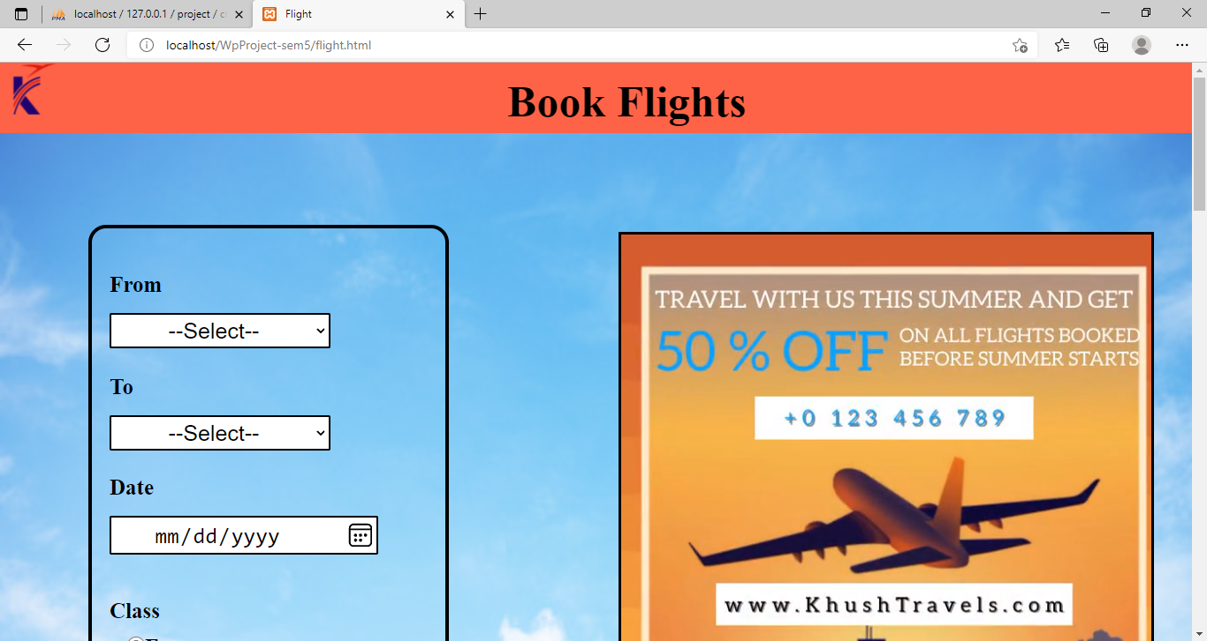

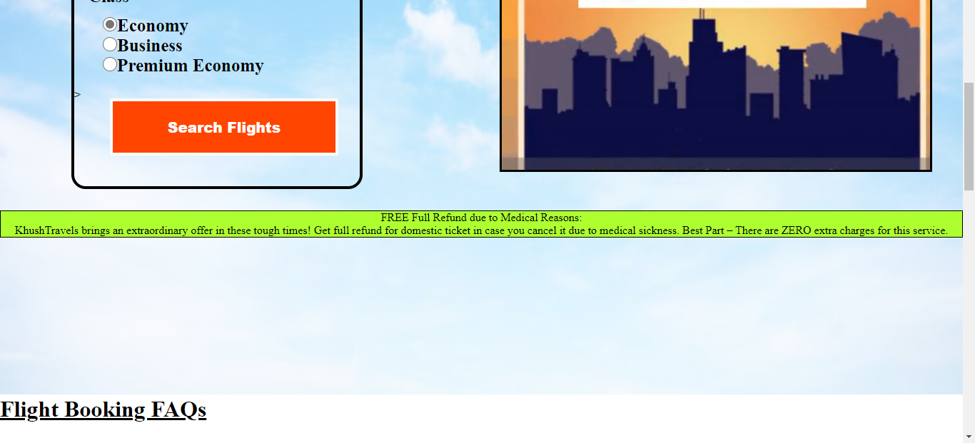

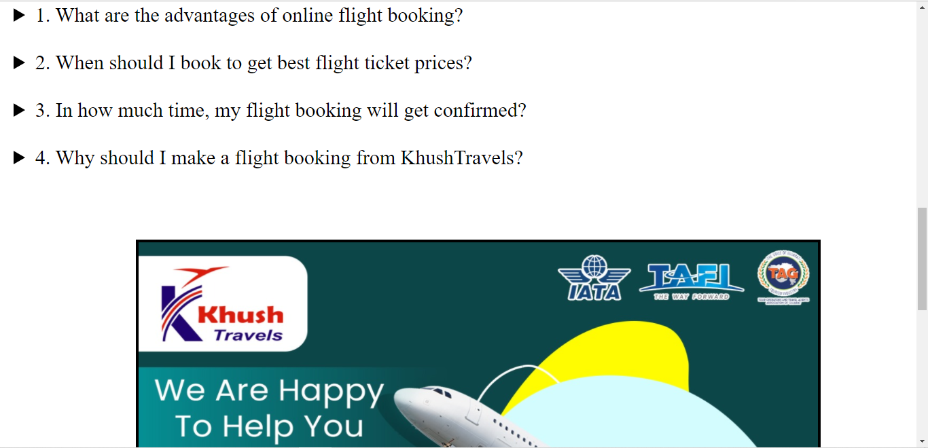

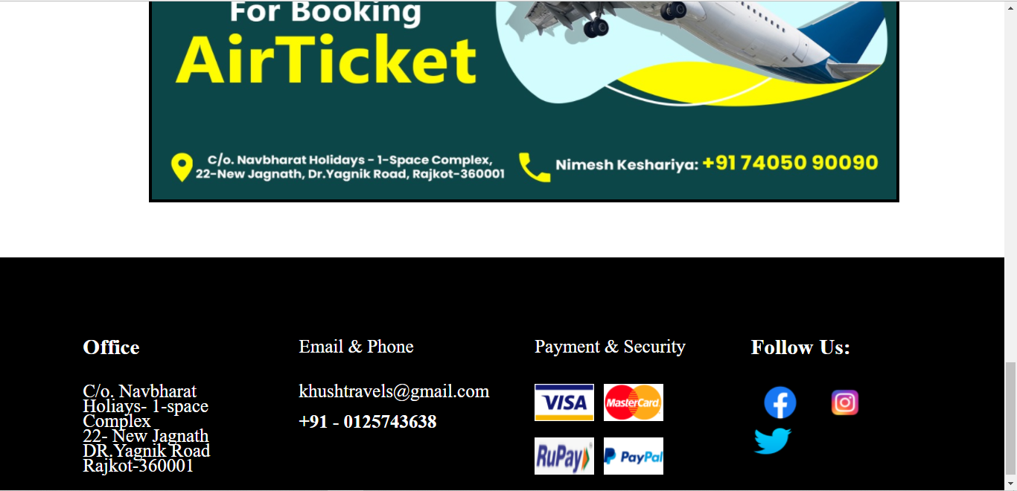

**3. Page that pops up when user clicks Trains option under Transport Menu:**

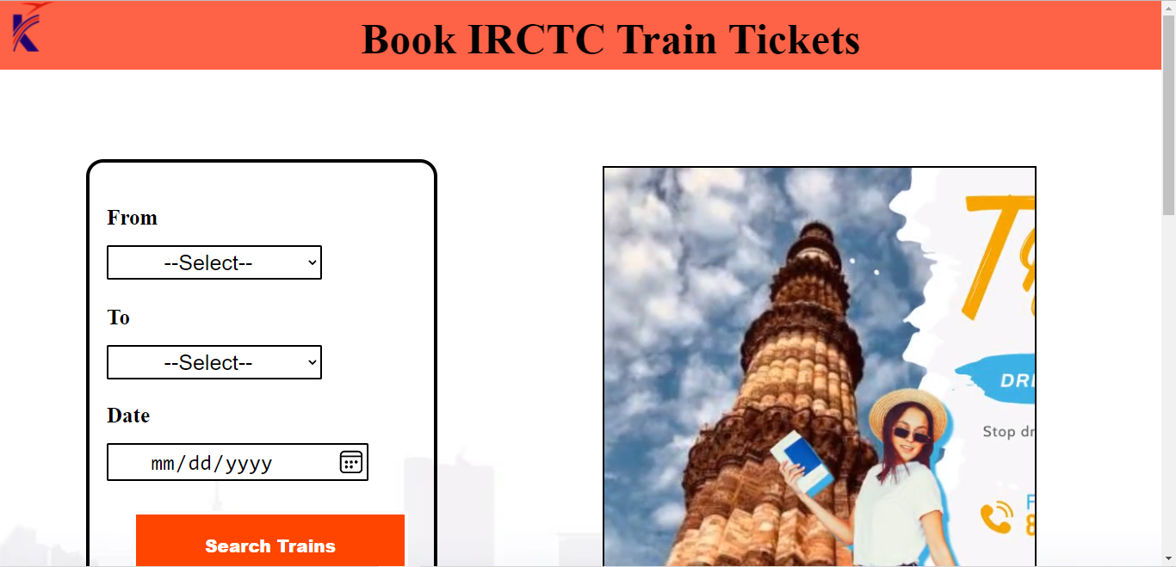

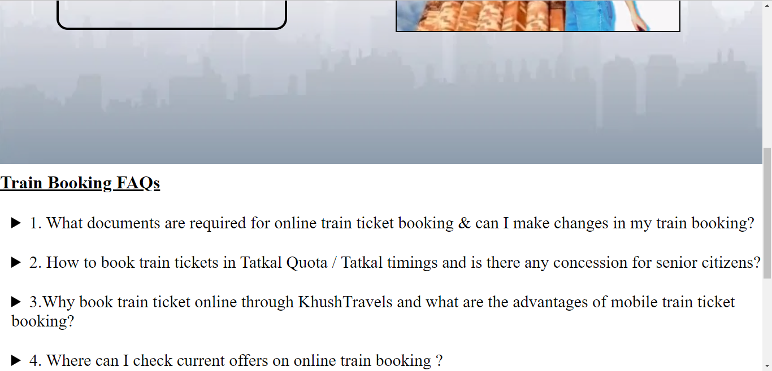

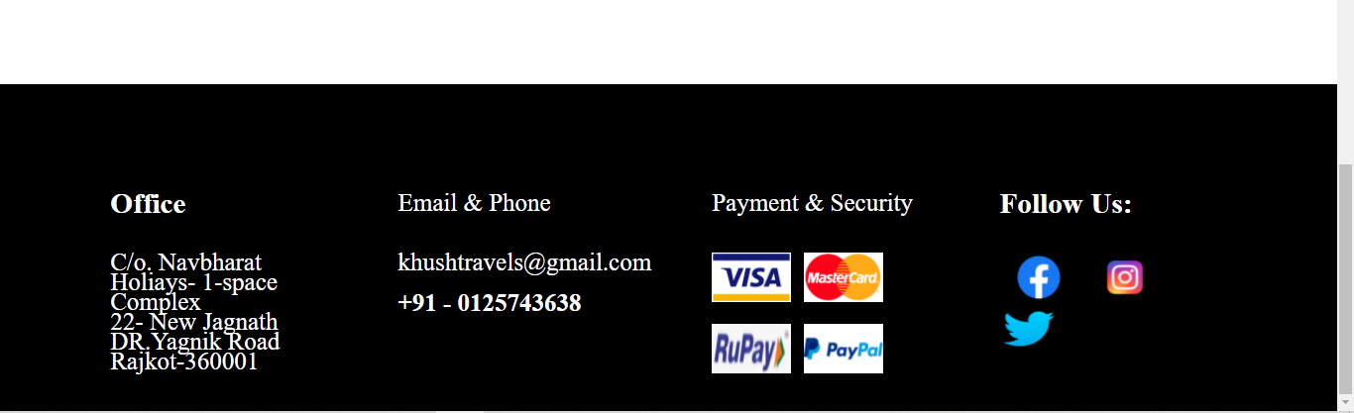

**4. Page that pops up when user clicks Bus option under Transport Menu:**

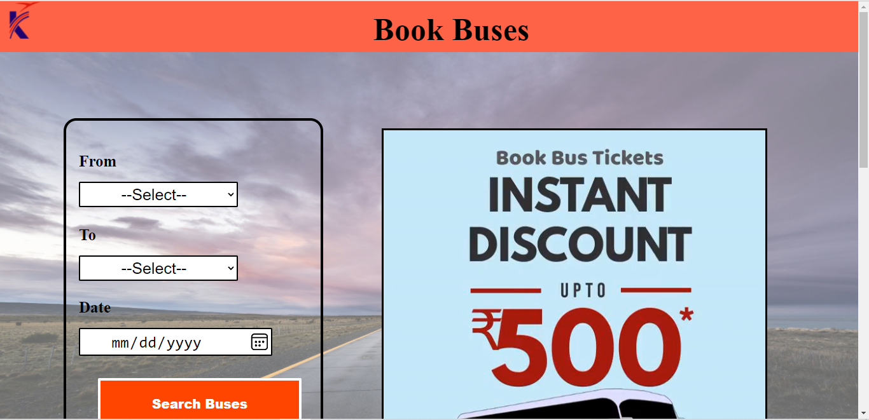

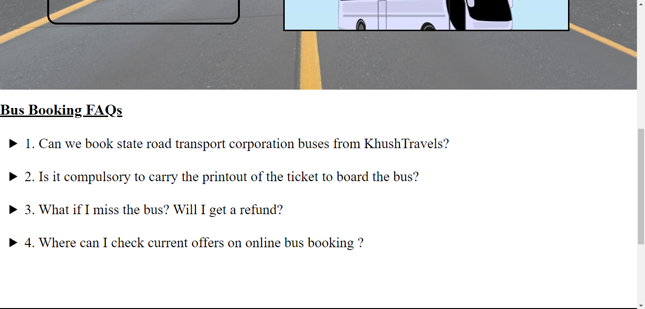

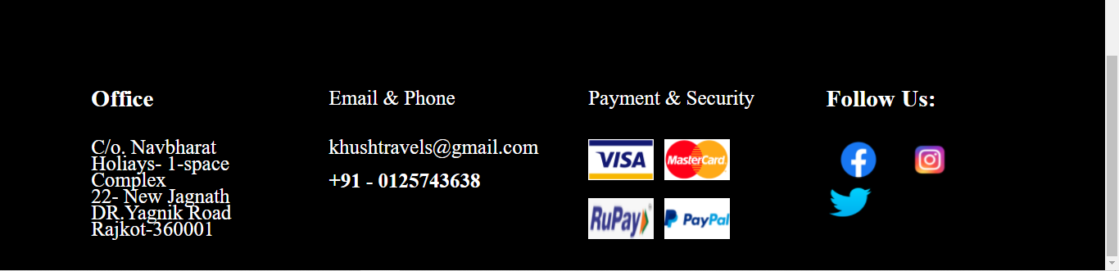

**5. Page that pops up when user clicks Hotels option:**

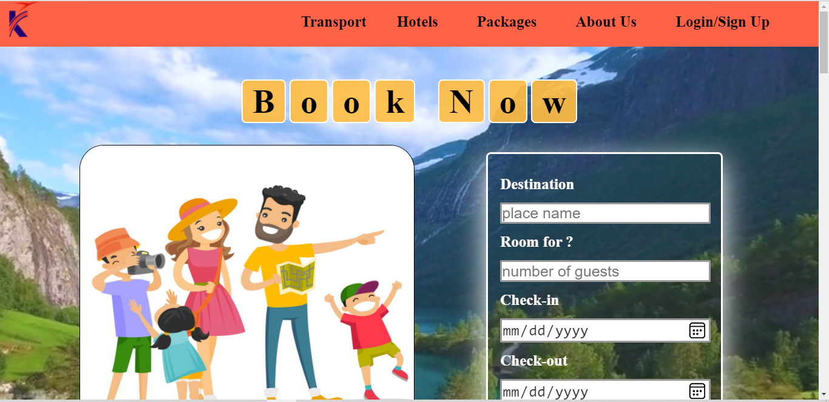

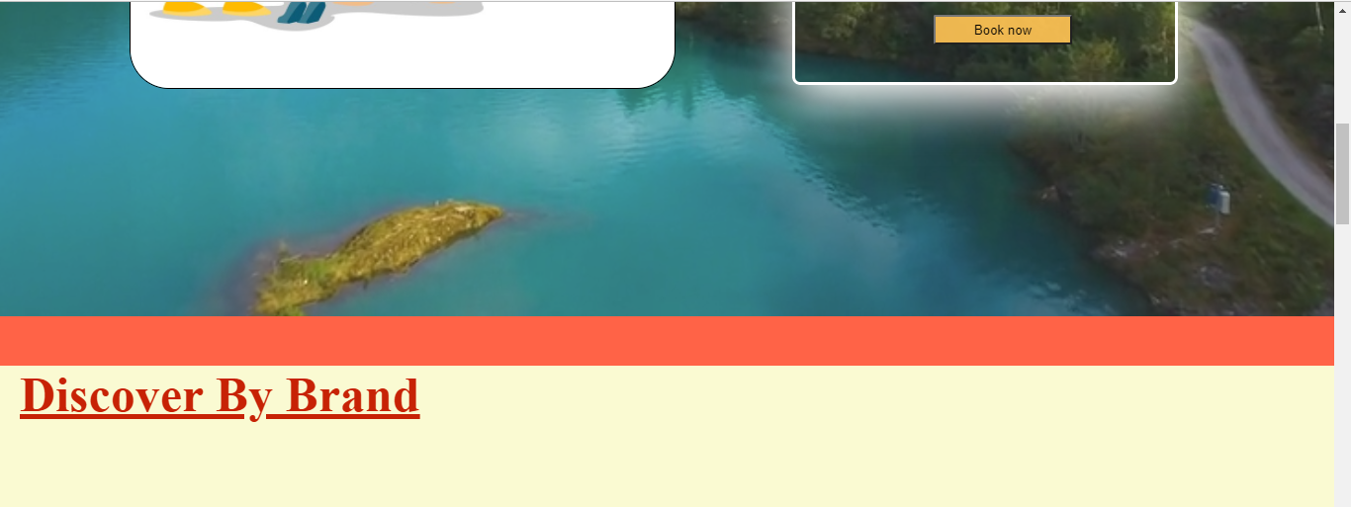



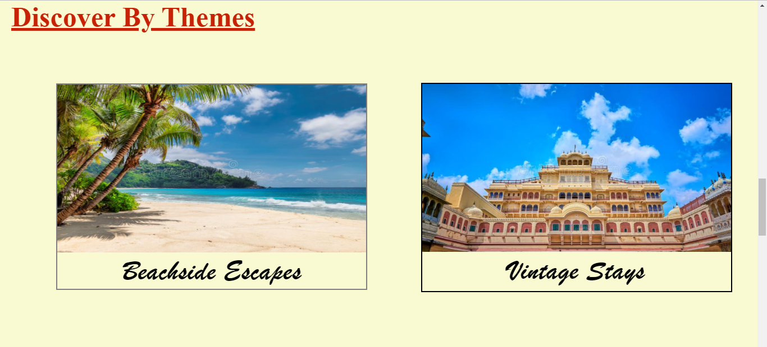

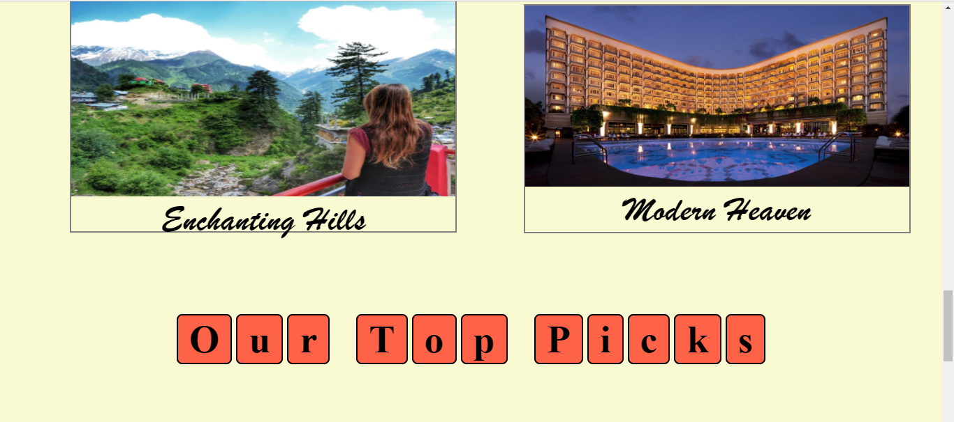



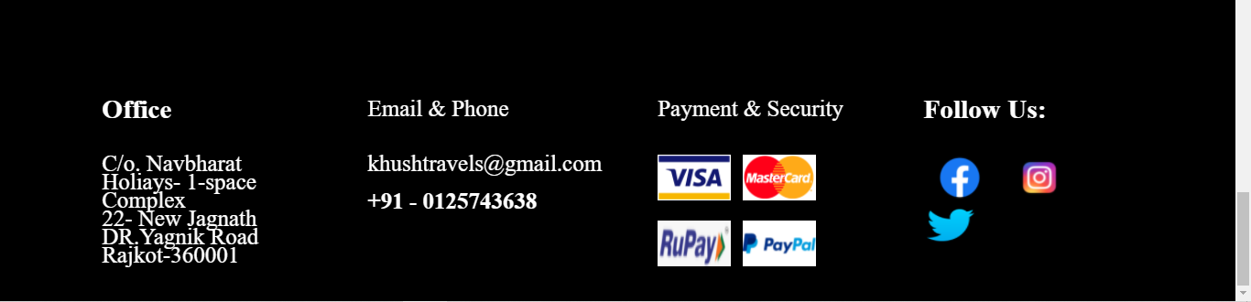

**6. Page that pops up when user clicks Packages Option:**

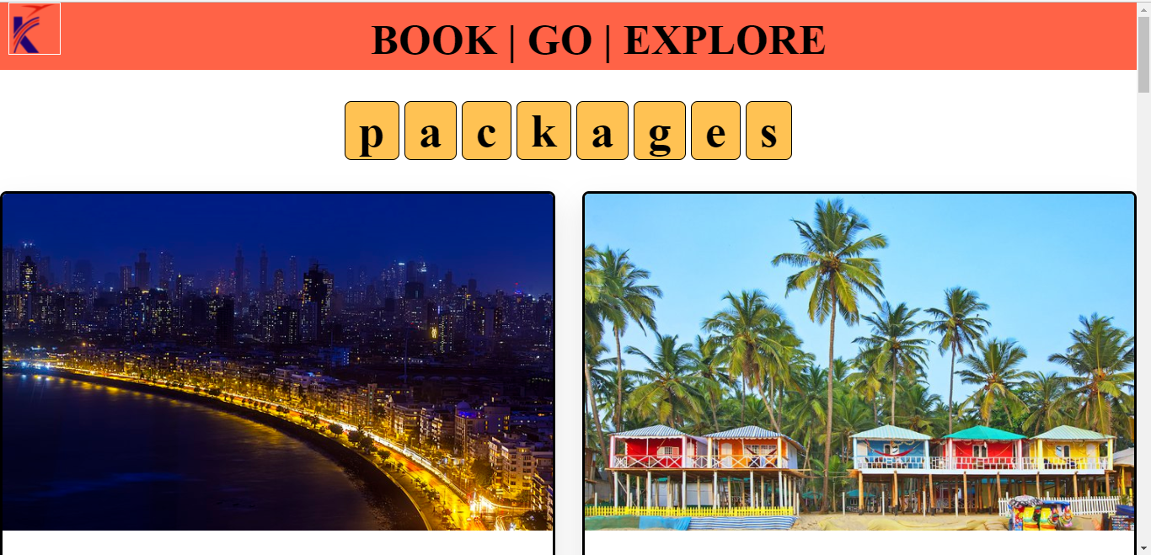

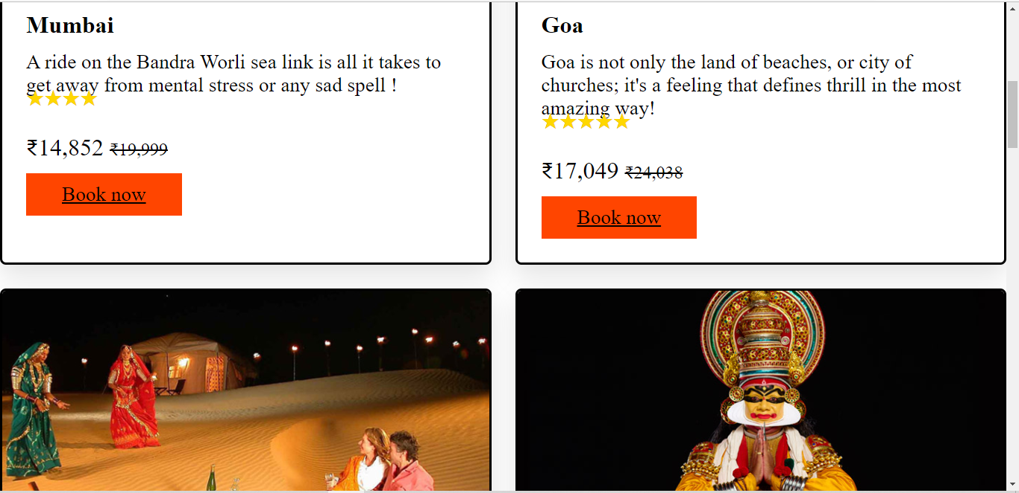

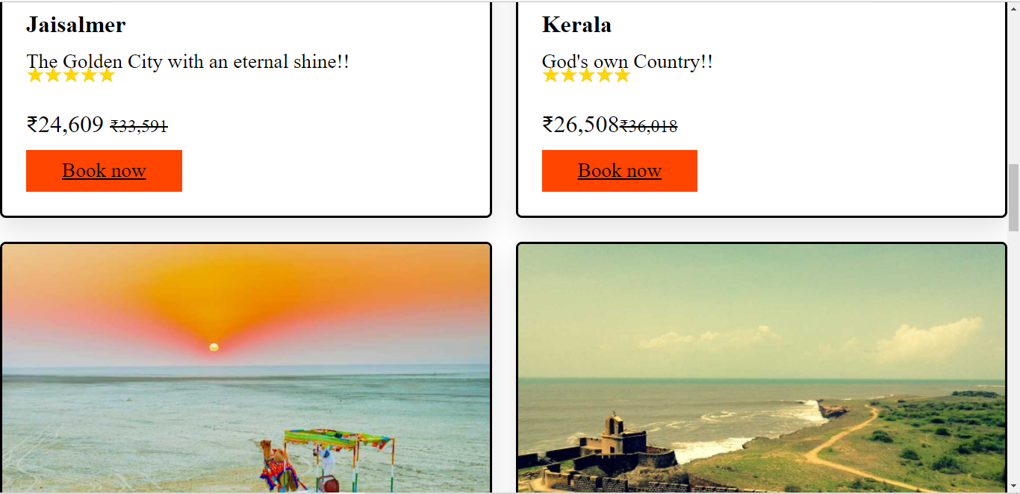

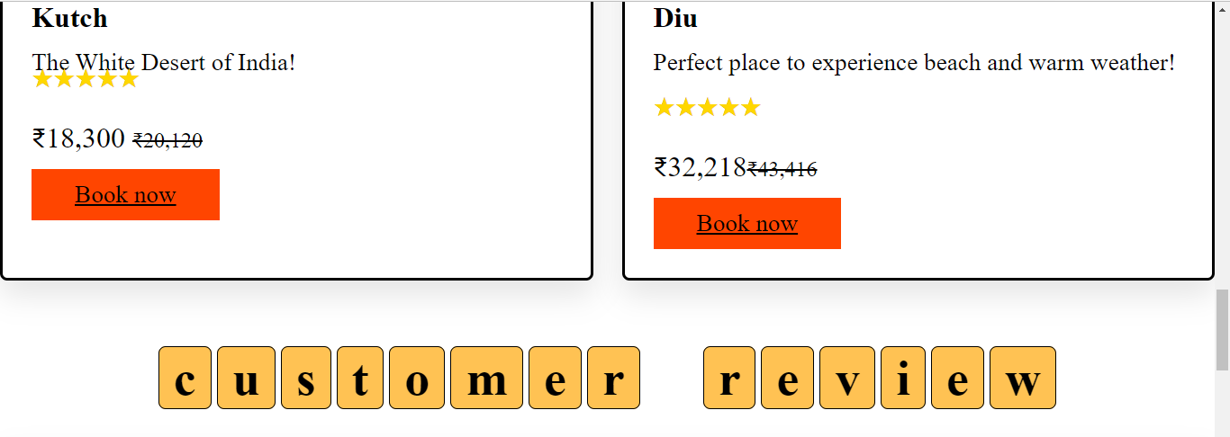

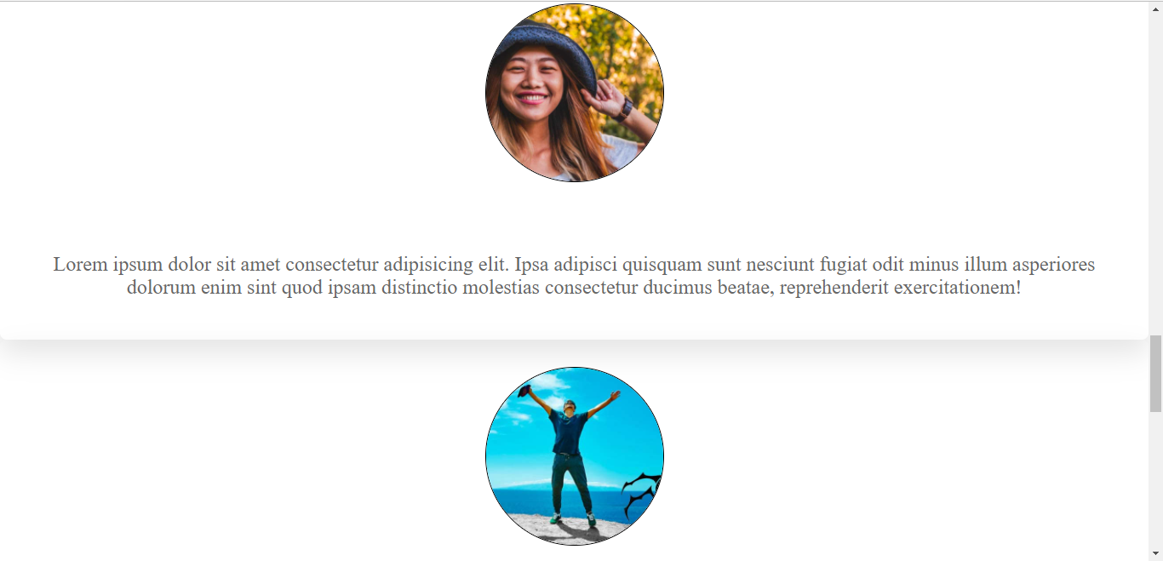

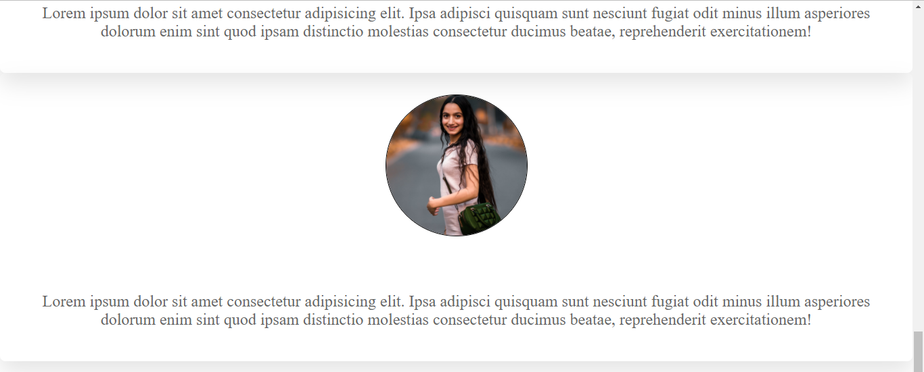

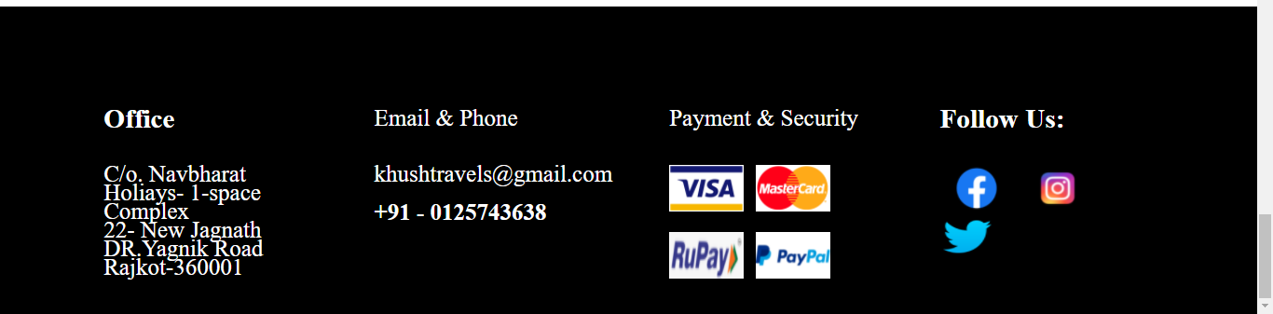

**7. Page that pops up when user clicks on About Us:**

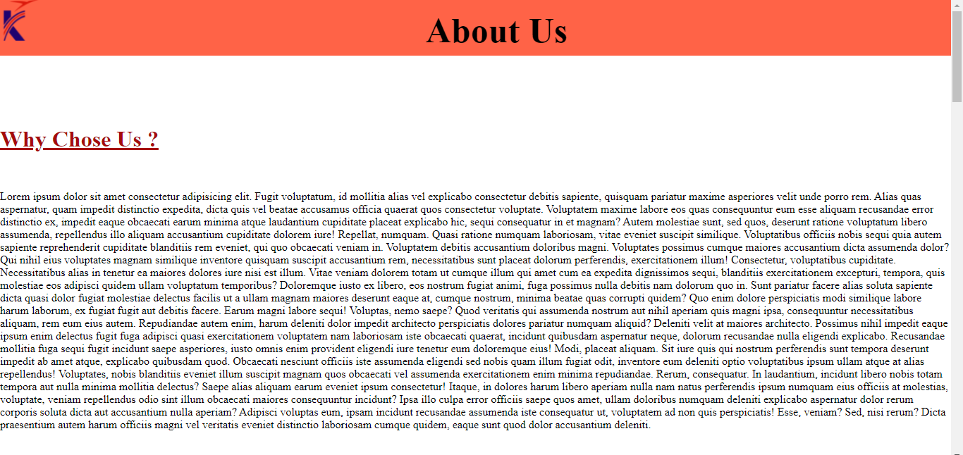

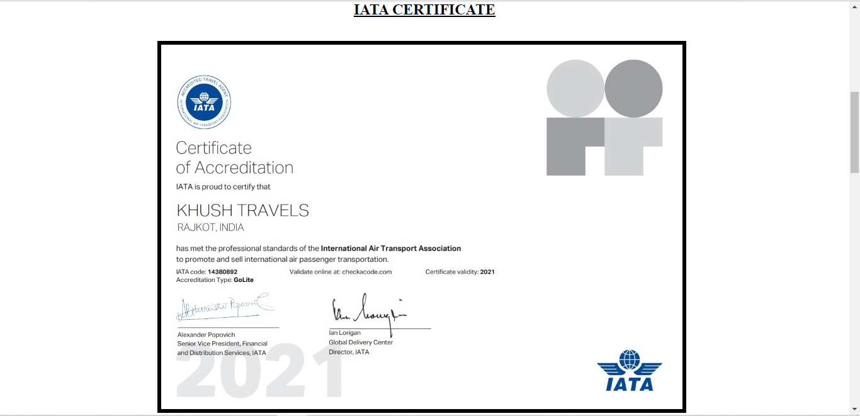

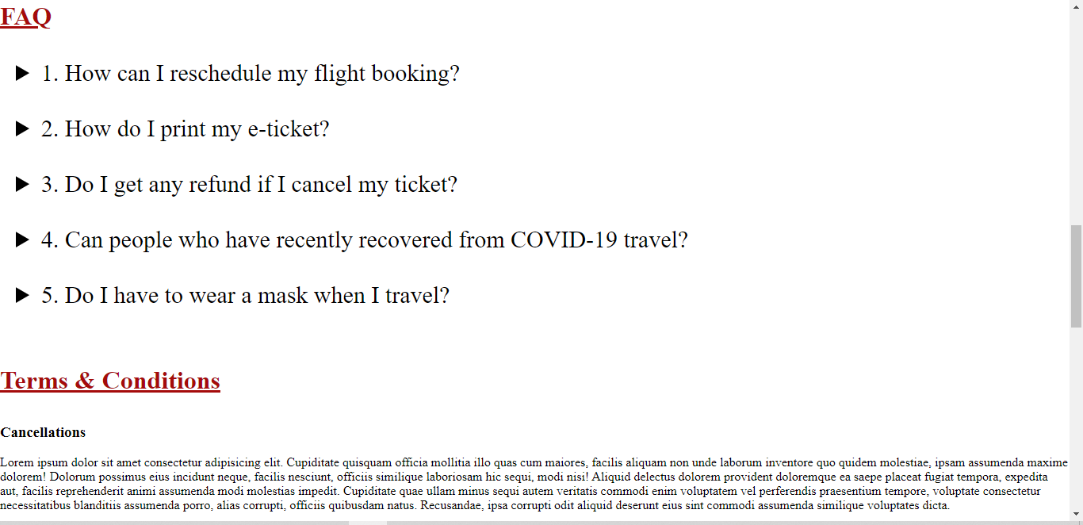

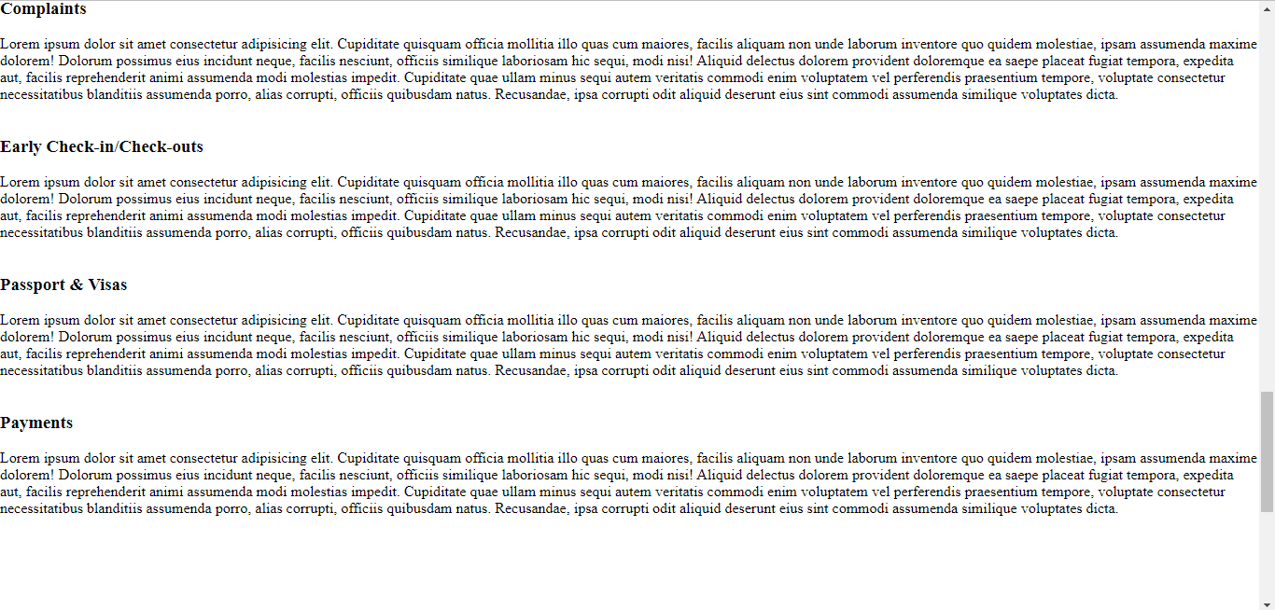

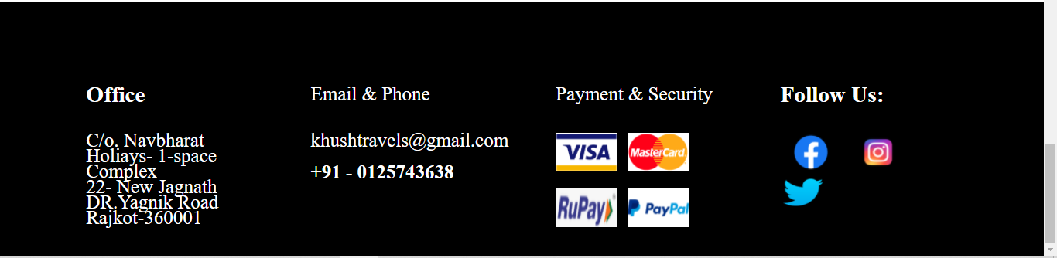

**8. Database Created & Login Page (For Existing User):**

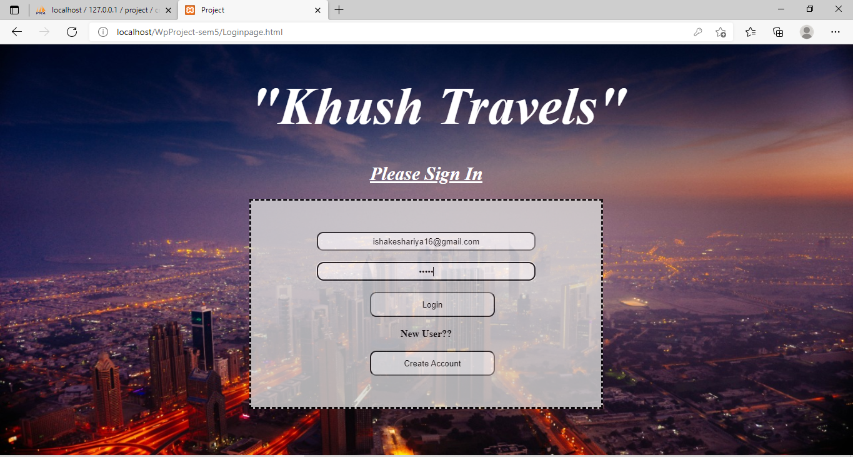

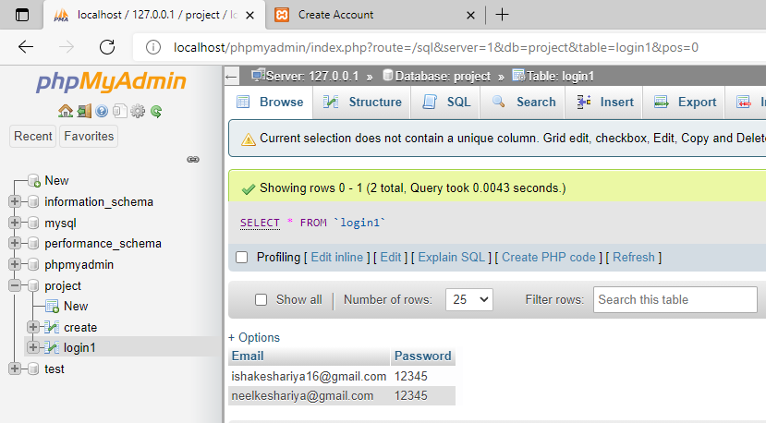

**9. Database Created & Signup Page (For New User):**

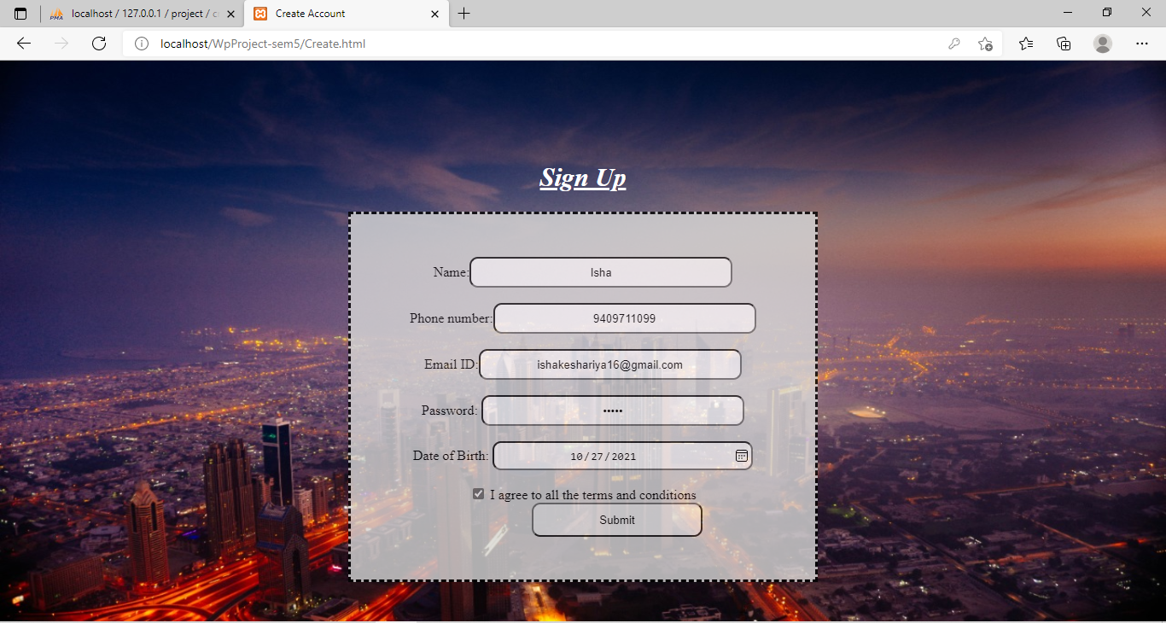

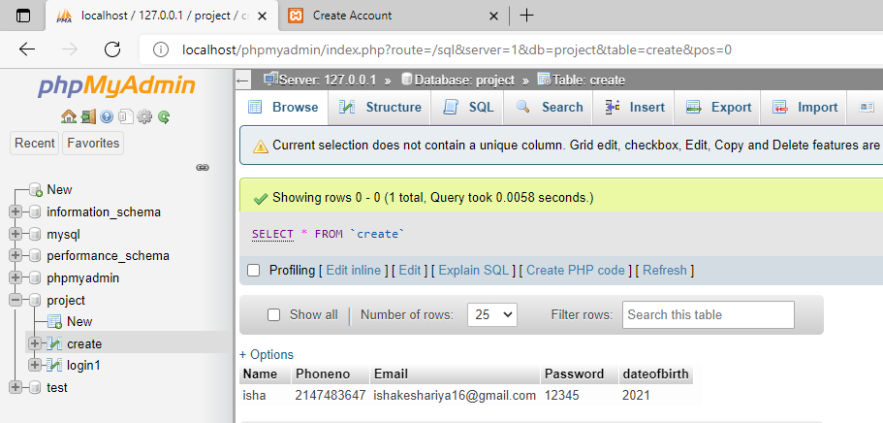

**DEPLOYMENT OF WEB APPLICATION**

* *Write about deployment about your mini project*
* *Plan of the deployment*

Presently, there is a lot of add ones to be employed in this mini project like putting in the offers and schemes for customers along with making a page by which customers can easily cancel their booking and initiate a refund. Along with it, the page needs to be linked to the bank account of the customer to ease the transactions and web security is also the component that needs space here, so for now, we are not intending to deploy this website. As time permits in the future, we shall work on this again and would surely deploy it once completed.

**CONCLUSION**

The intention and purpose of this mini-project are acquired. By delivering an exceptionally rich graphical user interface our web page designing is straightforward and in aesthetician form. Flexibility in designing makes user analyze their imagination and thus, even novice users can aspire and fulfil the desire of web page designing. We have accomplished the task of designing a simple and elegant web page which is user friendly and easy to understand.

**REFERENCES**

* <https://youtu.be/K4aa7ruovg0>
* <https://youtu.be/ThaIBFd387A>
* <https://youtu.be/A4GRk5R9-6s>
* <https://www.w3schools.com/>
* <https://stackoverflow.com/>